SMART LOCK MANUAL
BDL 9621

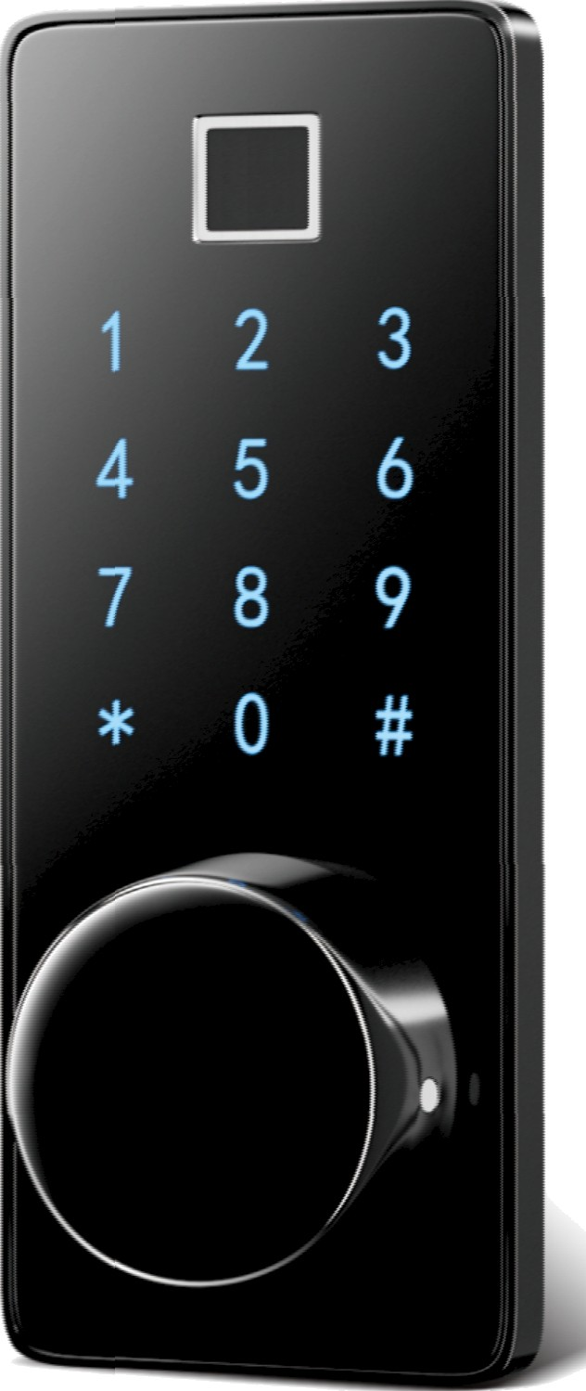
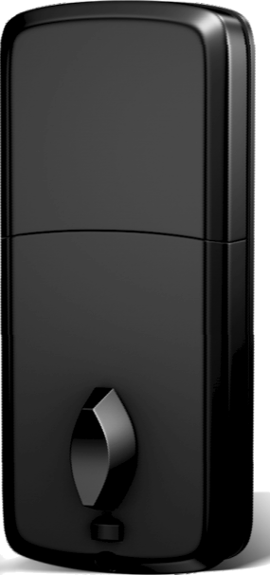

Contents
- Product Introduction. 1
  - Description. 1
1.2 Technical Specification.............................. 1
- Lock Setting. 2
2.1. App Installation.................................. 2
2.1.1. Auto connecting................................ - - 2
2.1.2. Auto Scan Mode................................. 3
2.1.3. Add Manually Mode. 4
2.2. Add Bluetooth Gateway........................... 5
2.3. Add Lock to Bluetooth Gateway..................... 6
(Alexa Setting Alexa Speaker Setting)
2.4. Add Fingerprints.................................. ' 11
2.5. Add Passwords.................................. 11
2.6. Add Cards......................................-- -- - 12
2.7. Add Temporary Code............................... 13
2.8. Modify & Delete Code.............................. 16
2.9. Motion Code. 16
2.10. Double Unlocking Setting........................ 17
2.11. Language Setting. 17
2.12. Volume Setting................................. 17
  - Auto/ Manually Unlocking Setting................... 18
  - Delay Setting. 18
3.Lock Functions Instruction............................... 18
3.1 Left/Right direction conversion........................ 18
3.2 Virtual passwords unlock............................ 18
3.3 App Unlocking & Locking.........................-.. - - - 19
3.4 Double unlocking................................. 19
3.5 Emergency power supply:.......................... 19
3.6 Electronic anti-lock................................. 19
  - Illegal intrusion alarm. 19
  - Low voltage alarm. 19
  - Illegal intrusion alarm. 19
  - Low voltage alarm. 19
4. Original list. 20

Product Introduction

Description
The M7BZ lock is the latest generation of smart Bluetooth locks of our company which is able to be unlocked by fingerprint, password app and card. There are the single unlocking mode and double unlocking
mode. Besides, it has many functions like voice prompting and temporary password setting that are suitable and convenient for the home and residential houses to use.

Technical Specification
Working voltage: 6VDC Working current: a300mA
Static current: a60uA Working temperature: -20 - 60°C Working humidity: 10-90 RH Low alarm voltage: 14.6V Suitable door thickness: 35-50 mm
Unlock modes: Password, MF Card, Emergency key, Fingerprint
and APP. Code length: 6 - 10 digits Card type: Mifare Card Fingerprint capacity: 100
User capacity: 300 users with password, MF card and fingerprint
Dynamic password: 1 (within 5 minutes) Virtual passwords length: 32 bits Automatic lock time: 1-1800s adjustable

In stalI atio n Vid eo Ope ratio n video

- Lock Setting

App Installation
Scan the bar code or search and download “ALTA WORLD “in app store. Install and register with your phone number.
There are three network ways as followed.(Note: Please power the lock.)

Auto connecting
Open ”ALTA WORLD” app •+ Get the lock close to the phone = • Auto appear

the lock page • Add it according to the picture below
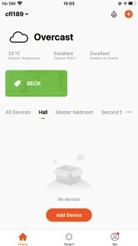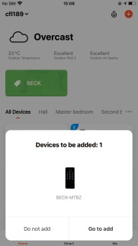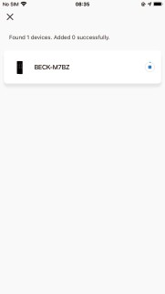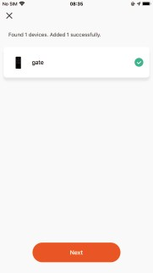

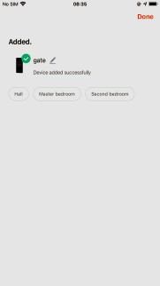
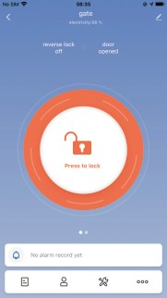

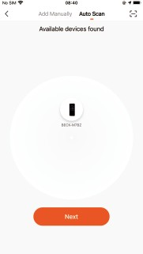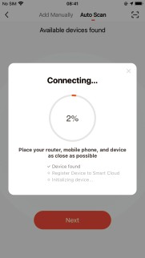

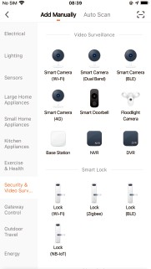
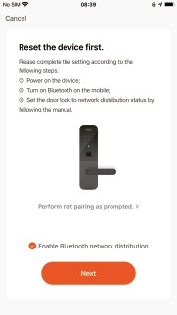

Add Bluetooth Gateway
Open ”ALTA WORLD” app • Click the O • Click the Auto scan • Start scanning the gateway • • Insert your code of Wifi • Waiting for the networking • Add it according to the voice prompt • Wait for success
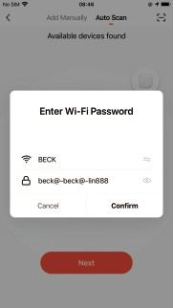
xxxxxxxx
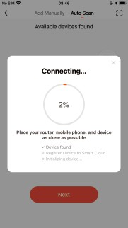
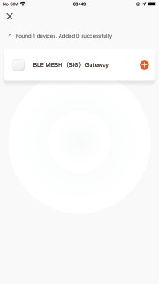
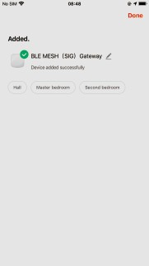
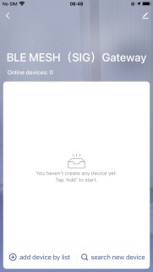

Open ”ALTA WORLD” app • Click the O •+ Click Gateway Control •+ Click Wireless Gateway (BLE) • Activate Bluetooth network • Start scanning • • Insert your code of Wifi • • Waiting for the networking • • Add it according to the voice prompt • Wait for success
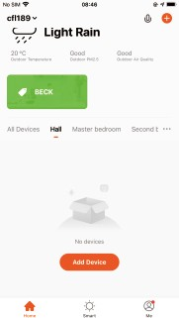
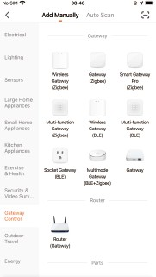
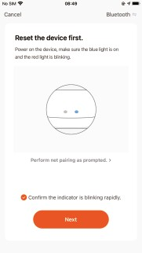
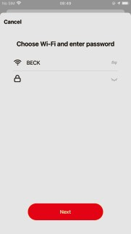

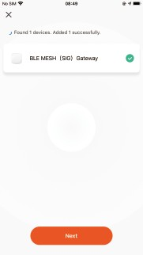

Note: After joining the Bluetooth gateway, remote unlocking can be realized at any time, and the unlocking record can be reported in real time at the same time
xxxxxxxx

Add Lock to Bluetooth Gateway
If you added the Bluetooth lock in the app, only Click the Add to list icon in the bottom left • add it to the gateway according to the picture below. Or not, click the Search new devices icon in the bottom right to add.
Tips: What makes the connection among the phone, lock and Bluetooth effective are within 10 meters and barrier-free communication range.
A Gateway can add 4 door locks within the communication rage.
xxxxxxxx
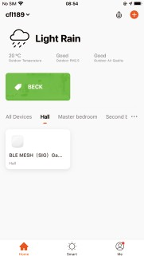
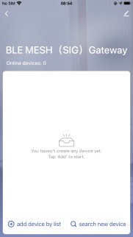
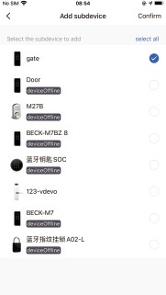
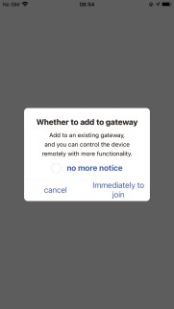
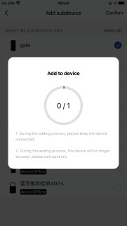
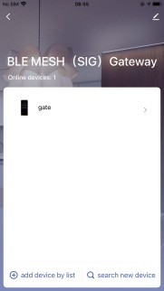

A gateway can add up to four door locks within the communication range, but 20 other Tuya devices
can also be added.
Alexa Setting:
Open”tuya smart”•+Click “Add device”•+Click Gateway Control •+Click wireless Gateway(BLE)•+Activate Bluetooth network•+Start scanning Click ” next”•+Wait for Connecting to succeed•+Click “done” after writing the name •+ Click “add device by list” to add the Iock•+Open “Alexa” •+ Click “more”and”Skills & Games“•+Click “SEARCH” input “TUYA”•+Click “Tuya smart”•+Click “ENABLE TO USE”•+Click ”Agree and links Back to “ACCOUNT LINKING”and click “CLOSE”•+Click “CANCEL” on”Discover Device”•+Click “LAUCH”•+Click “DONED Click "Lock” on “Devices Click “set”•+Open ”Unlock by APP”and “Unlock by voiced Create your Voice•+ code •+Test “lock Key”and “unlock Keys Click “HOME”•+Test “Alexa”can control the lock.
Add Gateway and Door lock refer to 2.2 and 2.3 please

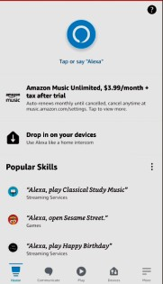
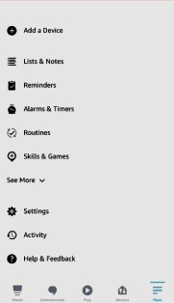
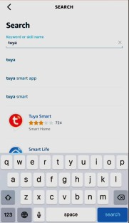
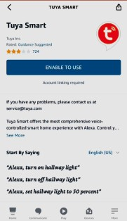
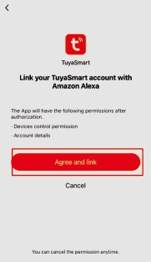
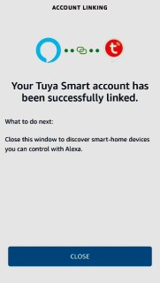
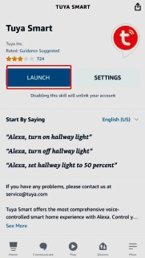

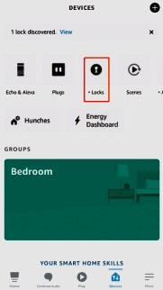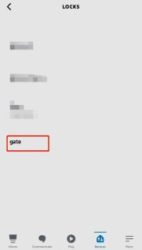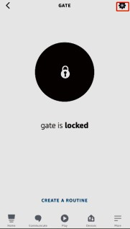
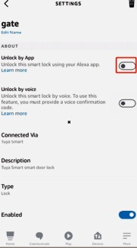
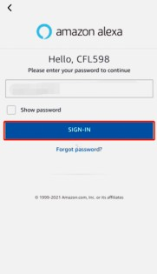
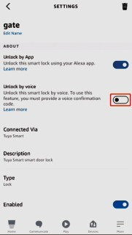
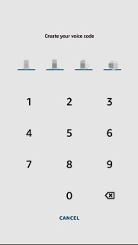

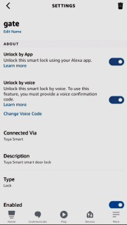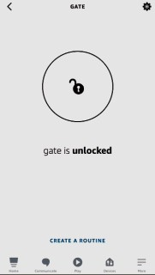
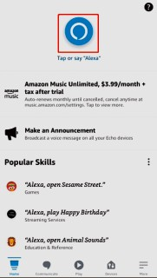

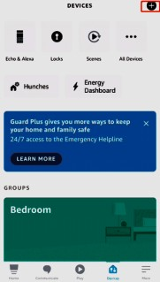
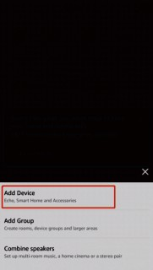
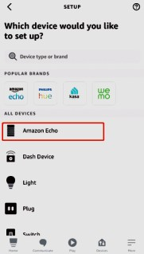
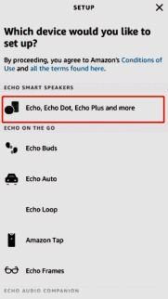
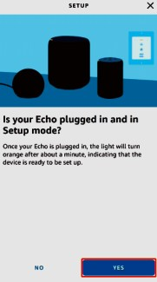
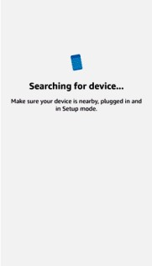
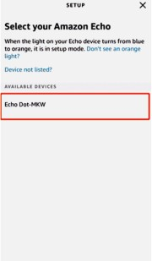
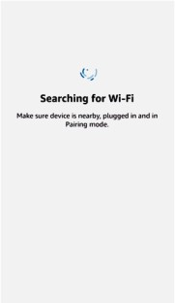
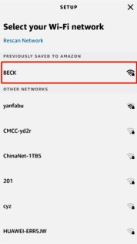
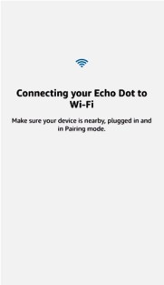
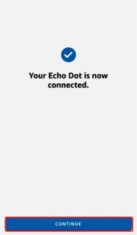
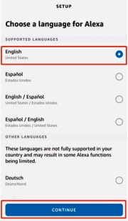

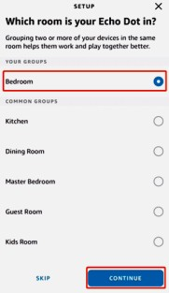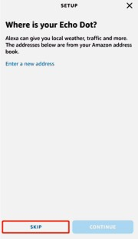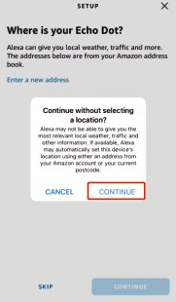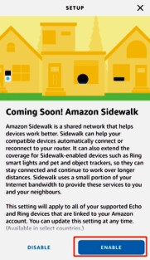
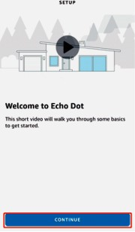
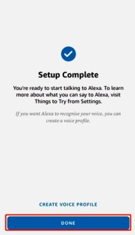
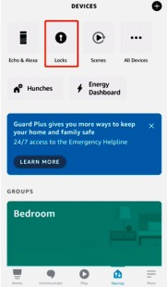
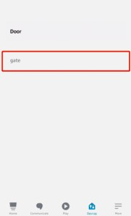
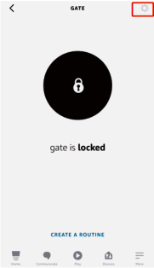
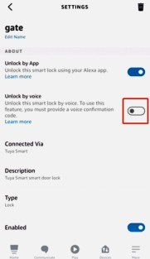
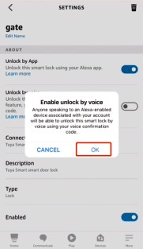
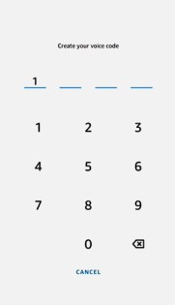
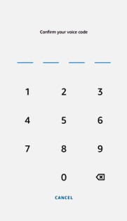
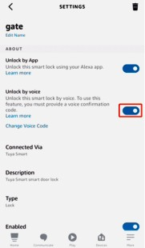

Add Fingerprints
Click the fingerprint management icon in setting page.
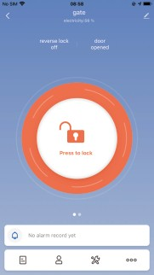
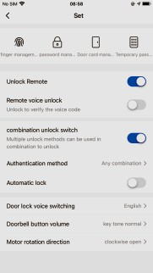
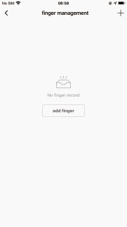
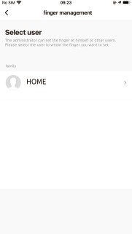
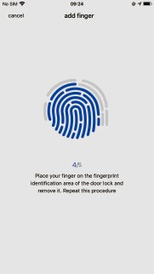
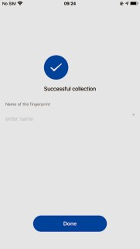
Press the same fingerprint five times according to the voice prompt. Tips: Add the maximal 100 fingerprints and modify or delete the name of users.
xxxxxxxx

Add Passwords

Click °°° =. Click “password management “ • Click”add password ”
- Click user •+ Enter your password •+ Enter your password name
- Click save • Wait for success
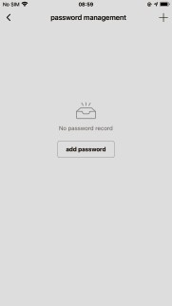
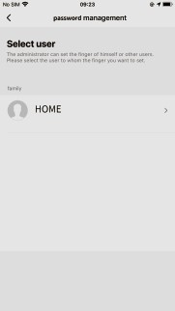

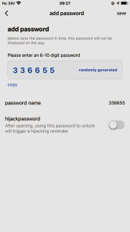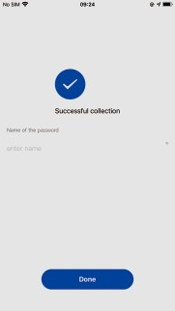
xxxxxxxx

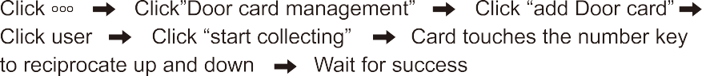
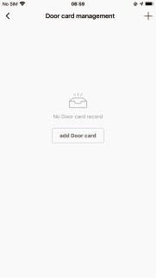
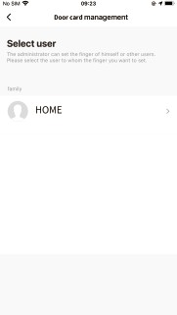
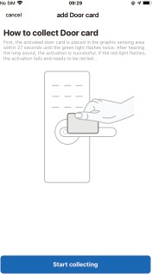
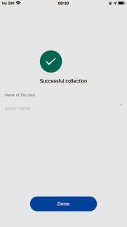

2.7. Add Temporary Code
Click the temporary code management icon in setting page.
There are two kinds of temporary code as followed:Online password and offline password

Online password
1.One-time code: it can be used one time in setting time.
xxxxxxxx
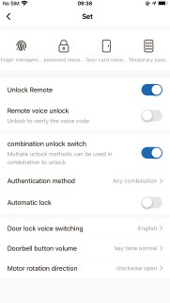
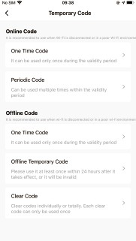
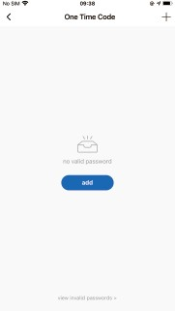
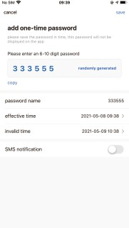

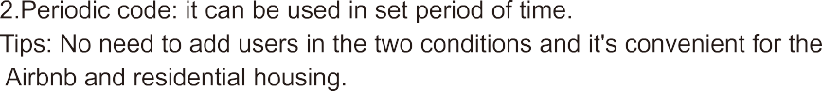
xxxxxxxx
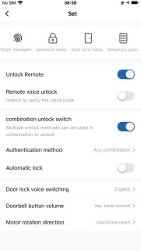
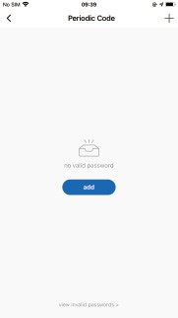
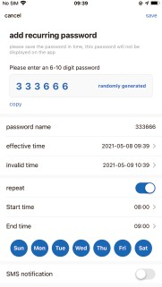

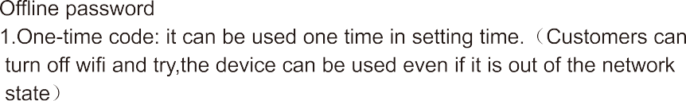
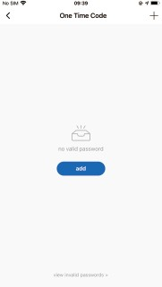

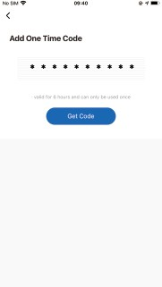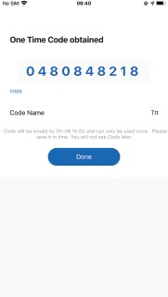
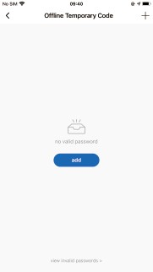
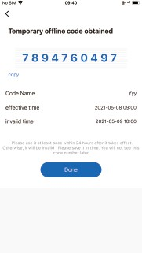

xxxxxxxx
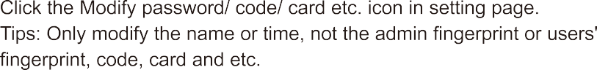

Motion Code
Enter the dynamic password generation page by swiping the left Generate the password generation.
Tips: Motion password valid in 5 minutes.
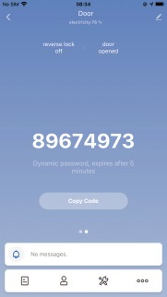

Double Unlocking Setting
Open/Close the double unlocking icon in setting page.
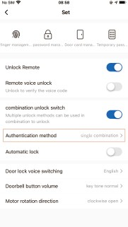
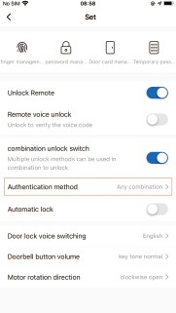

Language Setting
Click the Language icon in setting page.
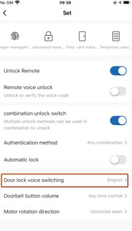

Volume Setting

Click the Volume icon in setting page.
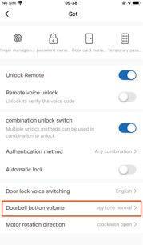

Auto/ Manually locking Setting
Click the unlocking or locking in setting page.
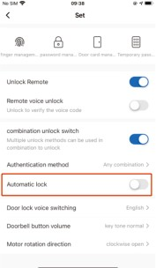

Delay Setting
Open the auto locking and add or subtract time in setting page. The longest setting delay is 1800s.

Lock Functions Instruction

Left/Right direction conversion
This lock has a left-right conversion function. When the lock is changed from right (R) unlocking to left (L) unlocking, the toggle switch in the rear lock body needs to be turned from R to L position.

Virtual passwords unlock:
Normal password unlocking:
Enter the correct password Press the [#J to confirm unlocking.

Virtual password unlocking:
Enter any Code Enter the correct password Enter any number Press the E#J to confirm
For example, the password is 666888; enter "any number + 666888 + any number" + [#], effectively preventing people from prying your password.
Note: The middle process must be entered the correct password.

App Unlocking & Locking
Click your lock in the app Long press the Blue unlocking icon to unlock the lock / Long press the Red locking icon to lock the lock. Text prompts
in the app.

Double unlocking
Unlock the door by the double combination of password + password or card
+ card or password + card.
First, enter a set password or card and press E#J to confirm, then there will be voice prompt "Combination Unlocking. Please verify other users", then enter another set of password or card within 8 seconds and press [#] key to confirm, finally the voice prompts the door unlocked and reports
the unlocking number.

Emergency key unlocked:
Remove the cover of key hole, insert the key into the key hole and rotate 90° to unlock.
Note: Please keep the spare key outside in a safe place in case of product failure or improper operation.

Emergency power supply:
Once the battery no power, you can charge the lock by inserting the Android cable into the USB port under the front panel, and then use the password or card to unlock the door. Please replace the battery in time.

Electronic anti-lock:
Press the anti-lock button under the back panel, there will be a voice prompt and message push on the phone. During the state, the ordinary user and card user can't unlock the lock from outside except the administrator can do it..

Illegal intrusion alarm:
When an illegal user performs 5 illegal operations, the voice prompts the “Illegal invasion. Owner notified”, in the meantime, voice alerts 20 times and the keyboard will be locked for 90s, but you can unlock the keyboard through the authorized card.

Low voltage alarm
If battery is lower than 4.6V, there will be a voice prompt”The battery is insufficient,pIease replace the battery” The lock can be unlock about 50 times at this time, please replace the battery in time.at the same time, the button light on the bottom row of the keyboard flashes quickly 3 times

  - Factory resetting:
Press the reset button on the back panel for 3 seconds, then voice prompts that the system is reset successfully.
The admin password will be reset to 666888, all user data is deleted and the unlock mode is the single open mode.Also can remove the device in the administrator’ s mobile phone App to restore factory settings

Original list:

Lock 1 set
Key 2 pcs
Latch 1 set
Screws 1 bag
Installation rubber 2 pcs
Manual
Hole drawing Screwdriver Lock catch Mifare Card
1 pcs
1 pcs
1 pcs
- set

pcs

